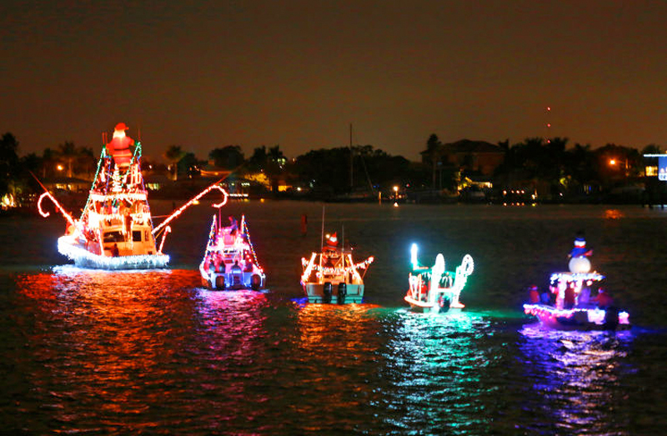
Marathon Sail & Power Squadron
Boot Key Harbor 26th Annual
CHRISTMAS BOAT PARADE
Saturday, December 10, 2022

REMOVE POSTER AFTER 12/10/22

Ahoy Skippers…Enter your boat

Dinghies to Yachts

Power and Sail. Entry is free and open to all

$500 GRAND PRIZE FOR BEST OVERALL!

Plus $250 Prize for Best Decorated Boat in Each Division, Over 30’ and Under 30’
Special Prize for Dinghy winner $100

To REGISTER your boat, go to www.BootKeyHarbor.com and use the online registration form. We’ll send you a confirming email.
For any registration questions call Gregory Absten at 305.849.0285
Calling all Landlubbers for Saturdays’ Festivities… Parade Route: The Parade starts at dusk – approximately 6 p.m., from the West end of Boot Key Harbor (7 mile bridge side) and will slowly wind its’ way East into the harbor towards Dockside Boot Key Harbor. We estimate passing the judges at Dockside about 6:45 pm or so. Some boats will continue on east past the condo’s to Yacht Haven Marina, then back out through the harbor. Post Parade Awards party at approximately 8:30 p.m. at Dockside. They will have a live band that night. For questions about Dockside, email owner Simone Mullis at simonemullis@gmail.com.

A captain’s meeting will be held on Friday or Saturday prior to the parade to go over the route and distribute numbers to display during judging.

Good viewing from Marathon Marina, Lazy Days South, Panchos Fuel Dock, Burdines Waterfront, and Dockside Boot Key Harbor - or the many homes and condos along the way.

HOSTED BY Dockside Boot Key Harbor

SPONSORED BY The Marathon Sail and Power Squadron
www.MarathonPowerSquadron.org
EXTRA PRIZES BY West Marine, Home Depot and Castaway Restaurant

Also note that the Marathon Yacht Club lighting of the fleet is Friday Dec 9th, and
The Key Colony Beach Boat Parade is Sunday Dec 11th.

