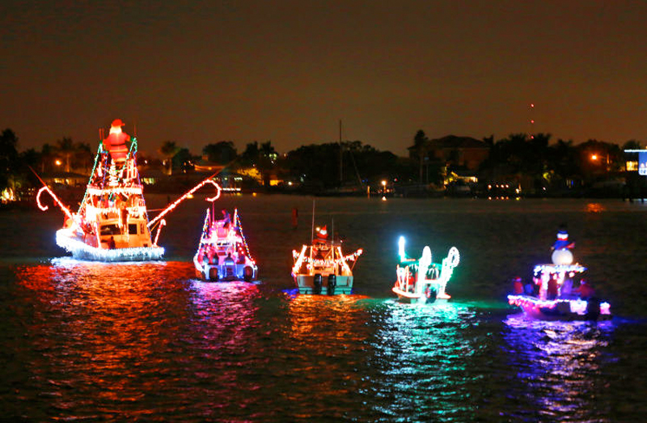
Boot Key Harbor 23nd Annual
CHRISTMAS BY THE SEA
Lighted Boat Parade
Saturday, December 14, 2019

Ahoy Skippers…Enter your boat

Dinghies to Yachts

Power and Sail

$500 GRAND PRIZE!

Plus Prizes for Best Decorated Boat in Each Division
Please call (305) 743-6575 for more detail and to register your boat.

Calling all Landlubbers for Saturdays’ Festivities… Parade Route: The Parade starts at 6 p.m., from the West end of Boot Key Harbor (7 mile bridge side) and will slowly wind its’ way East into the harbor towards Sombrero Marina Dockside, then back out through the harbor ending at Lazy Days South at Marathon Marina for a Post Parade Awards party at approximately 8:30 p.m.

Good viewing from Marathon Marina, Lazy Days South, Panchos Fuel Dock, Burdines Waterfront and Sombrero Marina Dockside. Parade boats also have the option to cruise to and from Castaway Waterfront Restaurant.

Friday Pre-Parade Festivities
On Friday, December 13th from 6 p.m. – 9 p.m. Walk the Docks at Marathon Marina to experience Christmas By the Sea and view the lighted boats up close prior to Saturday’s parade. Bring a un-giftwrapped new toy, and help us STUFF–A-BOAT. Let’s give all the children in our community a bright holiday.

